**Al-Jafari, Sammy A.**

I understand that what I put here is publicly available on the web and I won’t put anything here I don’t want the public to see – *Sammy Al-Jafari - 8/15/2024*

Sammy A. Al-Jafari |Sweet Alligator

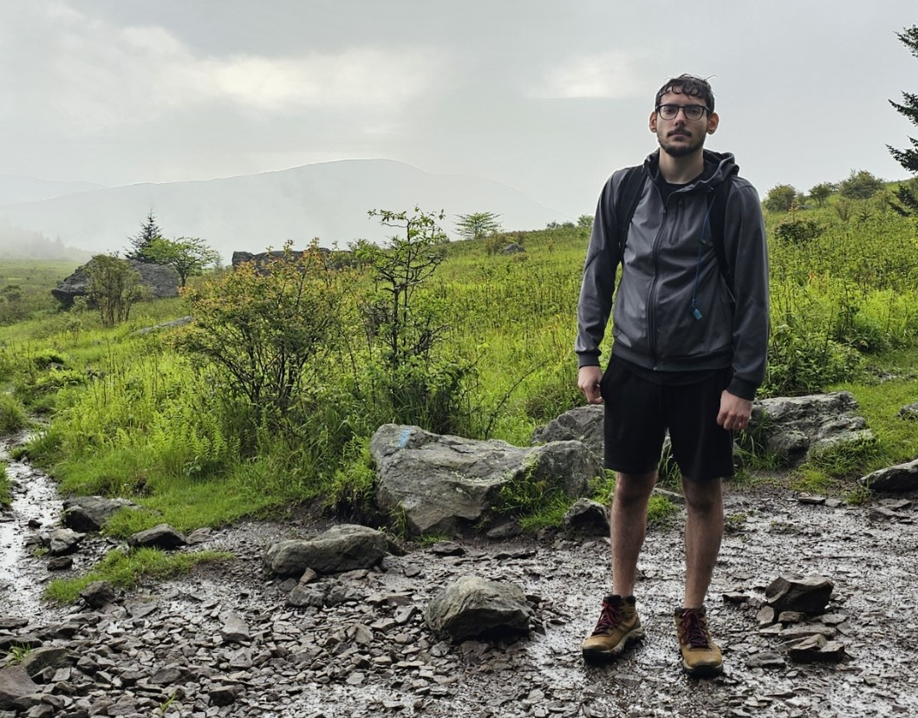

*Hiking in the Grayson Highlands, right before a storm*

* **Personal background:** I grew up in TN, moved to Raleigh around 2014, then to Charlotte in 2020.
* **Academic background:** Pursuing IT: Full Stack Programming
* **Background in this subject:** Have some experience in HTML/CSS from previous courses
* **Primary Computer Platform:**  Windows 10 PC, also have mac laptop that started school with.
* **Courses I'm Taking & Why:**
  + Web115 – Web Markup and Scripting-
  + DBA120 – Database Programming 1- to become more familiar with SQL programming
  + CTS240 – Project Management
  + CIS115 – Intro to Prog & Logic
* **Funny/Interesting item about yourself:** I don’t really exist - this is a sample you can use. Oddly people sometimes copy this sample, and then it still leaves instructions like these...
* **I'd also like to share:** If you don’t want to share you can not include this bullet at all, but if you include it, be sure to put something here.